In today’s fast-paced digital era, fraudsters are no longer just reactive; they are proactive, crafting sophisticated schemes that evolve faster than traditional fraud detection methods can keep up. For years, businesses leaned on manual investigations and classical ML / rule-based systems to identify fraudulent activities. While these approaches laid the foundation for modern fraud detection, they are increasingly unable to meet the demands of a world where fraud adapts and thrives in complexity.

**Think about this:** A team of dedicated investigators is tasked with reviewing thousands of flagged transactions every single day. Despite their expertise and diligence, how can they thoroughly examine every alert when they are drowning in sheer volume? The harsh truth is that some fraudulent activities will inevitably go unnoticed—not because of negligence, but because human capacity has its limits. Add to this the pressure of evolving fraud patterns, which are often subtle, multi-layered, and intentionally designed to slip through static defenses.

**Now, let’s consider the rule-based systems.**Imagine a system that flags transactions based on rigid thresholds—say, unusually high amounts or deviations from normal behavior. While these rules catch obvious red flags, fraudsters are clever. They observe, adapt, and innovate. They learn to stay just below these thresholds or mimic legitimate user behavior to bypass detection. Over time, such systems, despite their initial effectiveness, turn into predictable hurdles for increasingly creative fraudsters. Rules, after all, are only as good as their design—and fraud doesn’t play by the rules.

This is where **AI and ML** step in, transforming fraud detection from a reactive process into a proactive, adaptive defense mechanism. Unlike traditional systems, AI and ML are not limited to predefined thresholds or static criteria. Instead, they continuously analyze, learn, and evolve, making them an indispensable tool in the fight against fraud.

**Now, let’s reimagine the scenario:** Instead of burdening investigators with thousands of alerts daily, AI/ML systems prioritize and streamline the workflow. They analyze the flagged transactions and elevate only the most suspicious and high-risk cases for review. This reduces the volume of alerts investigators must handle, allowing them to focus their expertise where it matters most.

### **The Game-Changer: How AI and ML Transform Fraud Detection**

* **Pattern Recognition at Scale:**AI and ML models can analyze **millions of transactions** in real time, identifying hidden anomalies and connections that are invisible to the human eye. A single fraudulent transaction lost in the noise of millions? An ML model will detect it in seconds.
* **Real-Time Adaptability:**Unlike static rule-based engines, AI/ML models are dynamic. They learn from both historical fraud trends and live data, adapting as fraudsters evolve their tactics. Whether it’s a new phishing scam or a novel attack vector, AI stays one step ahead.
* **Nuanced Precision:**By analyzing a combination of behaviors, device data, geolocation, transaction patterns, and domain-specific features, AI models can uncover fraud scenarios too complex for traditional methods. This level of precision ensures that genuine transactions aren’t unnecessarily flagged, enhancing both security and user experience.

**The Reality Check**Fraud is a moving target—it adapts, evolves, and hides in plain sight. Static rules and manual reviews, while foundational, are rigid and reactive. On the other hand, fraud operates like a chameleon, shifting its patterns to avoid detection. Without the power of AI and ML, we risk drowning in false positives while actual fraud slips away undetected.

### **Why We Still Need Manual Investigations and Rules**

Before we dismiss traditional methods entirely, let’s acknowledge their strengths. Rule-based engines are excellent at flagging obvious cases (e.g., a login from a flagged IP). Manual investigations bring in human intuition for complex cases requiring judgment. However, these methods are reactive, not proactive.

**The Sweet Spot**The future of fraud detection lies in the symbiosis of AI, ML, and traditional approaches. Imagine this:

* AI filters and prioritizes suspicious activities based on patterns and anomalies.
* Rule-based systems provide guardrails to prevent extreme cases of fraud.
* Human investigators focus on flagged cases, guided by AI insights to make better decisions.

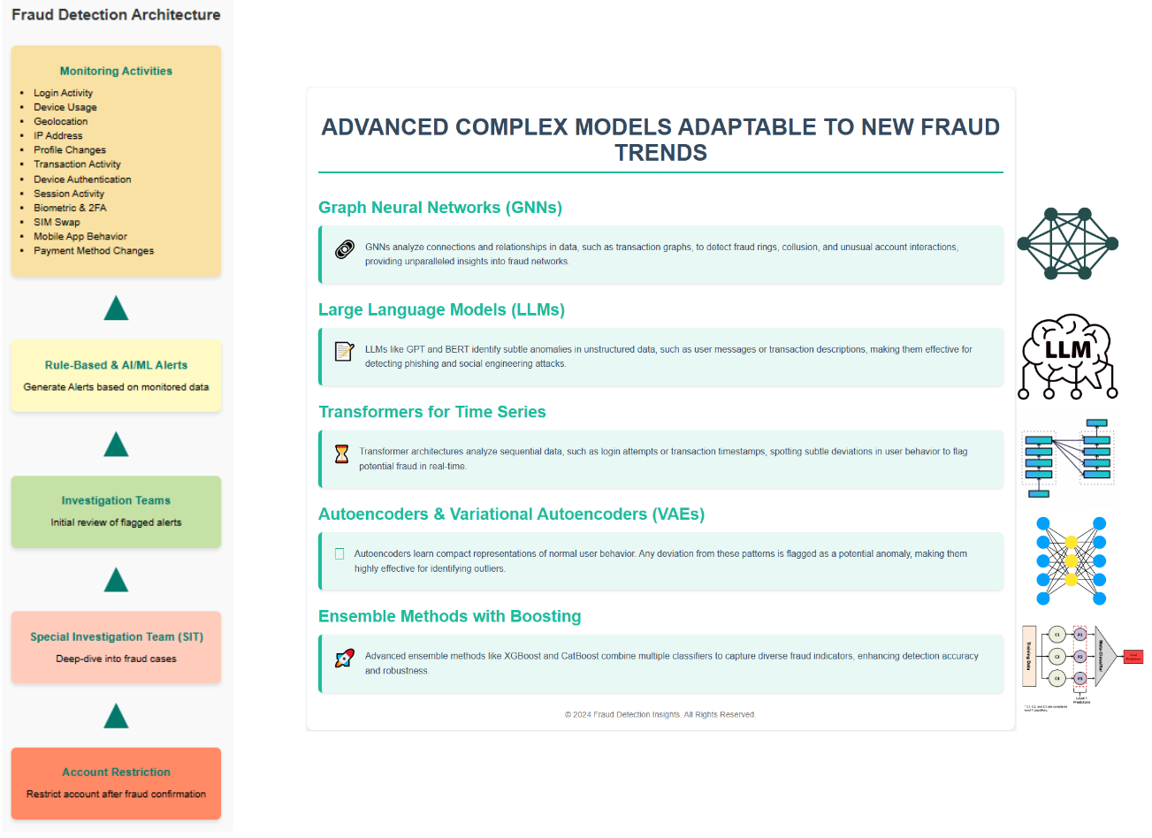

Complex models, leveraging state-of-the-art architectures like Graph Neural Networks (GNNs), Transformer-based models, and Large Language Models (LLMs), bring unparalleled sophistication to fraud detection.

* **Graph Neural Networks (GNNs):** Fraud often involves relationships between entities—users, devices, transactions, and accounts. GNNs excel in capturing these complex, interlinked structures, identifying fraud rings or collusion patterns that are undetectable with traditional methods. For instance, they can analyze transaction graphs to flag unusual clusters or links between accounts.
* **Large Language Models (LLMs):** LLMs, like GPT or BERT, are powerful in detecting anomalies in unstructured or semi-structured data, such as user messages, transaction descriptions, or web logs. They can identify subtle linguistic patterns or deviations in written communication that might indicate phishing or social engineering attacks.
* **Transformers in Time Series Analysis:** Transformer architectures handle sequential data, such as login attempts, transaction timestamps, or device usage patterns, with remarkable efficiency. They allow for the detection of nuanced behavioral anomalies over time, highlighting deviations from a user's typical activity.
* **Autoencoders and Variational Autoencoders (VAEs):** These models are invaluable for anomaly detection. By learning compact representations of normal behavior, they can flag deviations—indicating potential fraud—with high sensitivity.
* **Ensemble Methods with Boosting:** Advanced boosting techniques, such as XGBoost or CatBoost, effectively combine multiple weak classifiers, capturing diverse fraud indicators from various features.

By integrating these advanced models, fraud detection systems can handle diverse data types, adapt to new fraud strategies, and reduce false positives while maintaining high recall, making them indispensable for modern fraud detection efforts.

Our in-house models utilize advanced deep learning architectures to tackle various fraud detection challenges. Specifically:

1. **Deep Learning Models for Check Alterations:** We leverage deep learning techniques to analyze and detect alterations in checks, identifying subtle changes in text, signatures, and other critical elements to flag fraudulent checks.
2. **Image Processing for Treasury Check Barcode Decoding:** Using advanced image processing techniques, we decode barcodes on treasury checks, ensuring authenticity and preventing counterfeit checks from being processed.
3. **Graph Neural Networks (GNN) for Deposit Fraud:** GNNs are employed to analyze transaction networks, detecting suspicious patterns and behaviors related to deposit fraud by understanding relationships between users, accounts, and transactions.
4. **Autoencoders for Account Takeover (ATO) Fraud Detection:** Autoencoders are used to learn normal user behavior patterns. Any significant deviation from these patterns, such as changes in login locations, device information, or user activity, is flagged as a potential account takeover, helping to identify fraudulent activities early.